Anderson Leadership Solutions
Dave Anderson, President

Leadership Position Paper

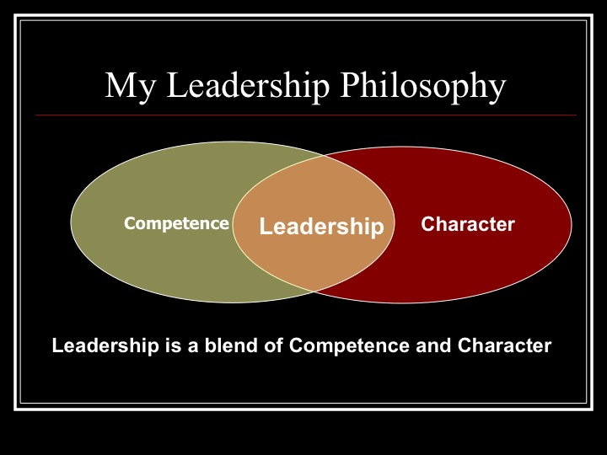

© Dave Anderson 2012 All Rights Reserved

I believe leadership is inherently a positive term. Some well known experts whom I respect define leadership as influence, or influence towards a common objective. However, I believe these definitions do not go far enough.
In my mind, being a leader is a positive statement. There is a moral component to leadership. Leadership is not simply about influence. If I convince someone to perform immoral acts, I am influencing them, but I am not a leader. Therefore. I do not use the word leadership when discussing historical figures like Adolf Hitler or Joseph Stalin.
I believe leadership is a blend of competence and character. To be a leader, one must be competent at accomplishing things a leader needs to accomplish. But a leader must have strong, positive moral character as well. Without both, a person in leadership is doomed to fail.
At work, in the news and in the history books, failures in leadership are almost never a result of failures in competence. They are failures in character. Here is a short list of examples I’ve seen and the character trait that was exposed in those failures:
- Bernie Madoff was an expert money manager. But, he lied to his clients and stole millions. He lacked integrity not competence in handling money. He is doing time.
- A sales manager I know could teach others how to sell and was a great salesman himself. But he badgered sales people to sell more so “I can win this year’s award trip.” He was selfish not incompetent. His people were disgruntled and low performers. He was fired.
- Adolf Hitler was a competent military strategist and politician. He also slaughtered millions of innocent people in concentration camps. He was perhaps the most amoral man to ever walk the earth not incompetent. Hitler’s name will forever be synonymous with evil in the history books.
- Leaders at Penn State ran an athletic department for years full of winning teams. But at the point of testing, they were unwilling to speak out or act when the allegations of abuse were first reported. That was cowardice not the inability to run an athletic department. That story isn’t finished.

© Dave Anderson 2012 All Rights Reserved

Competence is the price of admission to leadership. Competence is easier to identify, to measure and to train than a person’s character. That is why so many leaders and organizations only focus on identifying and training skills to the exclusion of character. But, it continues to be character issues that cause organizations so many problems.
To better identify and train character, it must first be defined:
I believe our character is our habitual way of operating.
Character:
- Begins with our thoughts.
- Our thoughts become our words.
- Our words lead to our actions.
- Our actions become habits.
- Our habits determine our character.
- Our character determines our destiny.

Individual and Organizational Character Formation
1. Character Formation Begins With My Thoughts: I must spend time filling my mind with positive influences.
Individual Character:
            - I must know what’s important to me and read about them: Values like Integrity, Trust, Courage… Sources include The Bible, Biographies of Leaders, Leadership books.
- I must spend time with people who already are where or who I want to be. I become most like the people I spend the most time with.
Organizational Character:
- We must develop and publish specific documents that define our vision, mission and values and be sure we spell out what each value looks like in practice not just in theory.
- We should reward and encourage professional development beyond just skill development.
© Dave Anderson 2012 All Rights Reserved
2. My Thoughts Become My Words: I must capture my bad thoughts and share my best ones.
Individual Character:
- I must speak with candor and speak aloud my convictions about right and wrong.
- I must be a problem solver by offering positive solutions not complaints.

Organizational Character:
- If we have a vision, mission and values on our website or in our marketing pieces, our organization must communicate them regularly to our teams.
- We must speak of character building values consistently and have discussions at all levels about how these values are to be practiced in real life.
3. My Speech Leads To My Actions: “Well done is better than well said.” -Benjamin Franklin
Individual Character:
- I must be authentic. If I say I believe in something, then I must ACT like it.
- I must be consistent. I must ACT on my convictions in every circumstance.
Organizational Character:
- We must inspect and expect high moral character from the CEO to the janitor.
- We must make the decision for the right reason even if it hurts revenues.
4. My Actions Become My Habits: Virtuous actions repeated over time become my habits.
Individual Character:
- I must follow my convictions in the small things, and the big things will be easier.
- I must act like there are no small decisions when it comes to my character.
Organizational Character:
- We must reward and publically recognize those who habitually display the character we wish our organization to exude.
- We must consistently filter our decisions though our core values.
© Dave Anderson 2012 All Rights Reserved

5. My Habits Determine My Character: WHO I am is determined by HOW I regularly operate.
Individual Character:
- What I do habitually over time becomes my character.
Organizational Character:
- The cumulative habits of the individuals within our organization is the character of our organization.
- If we as leaders do not like the habits of people within the organization, we have the responsibility for changing those habits.
- If no action is taken, the organization’s character will become what the leadership dislikes.
Our Habits Determine Our Character and Our Character Determines Our Destiny.
The destiny of an individual and an organization rises and falls based on their character. If I want to lead others I must take my own character development seriously. If my organization is to thrive in good times and in bad, we must find and develop leaders of character at all levels.
I can’t read a book or go to a training seminar or a Sunday sermon and suddenly be transformed into a leader of character. Becoming a leader of character is a life long pursuit that will determine my destiny.
If I maintain my focus on becoming a leader of character by following the steps above, I will become a person others believe in, want to follow and want to emulate.
If my organization dedicates itself to developing leaders of character at every level, my organization will lead our industry, change lives and possibly change the world.
That is what leaders do. Leaders lead change. That is a road worth travelling and a destination most people and organizations aspire to.

© Dave Anderson 2012 All Rights Reserved

